**Performance test for DeviceHistory**

Test Summary:

|  |  |
| --- | --- |
| Kernel Request | Retrieve all Device History Details |
| Base URL | https://integ.mosip.io |
| Execution Window | 2019/01/07 01:26 PM IST to 2019/01/07 01:57 PM IST |
| Maximum User Load | 100 |
| Tool Used | Jmeter |
| Average Response Time | 433 |
| Throughput Achieved | 38.84 |

Transaction Summary:

|  |  |  |  |  |  |  |  |
| --- | --- | --- | --- | --- | --- | --- | --- |
| Label | #Sample | Average | 90% line(ms) | Min(ms) | Max(ms) | Error% | Throughput/Sec |
| Retrieve all Device History Details | 87011 | 433 | 160 | 57 | 42123 | 0.02% | 38.84 |

Response Times Over Time

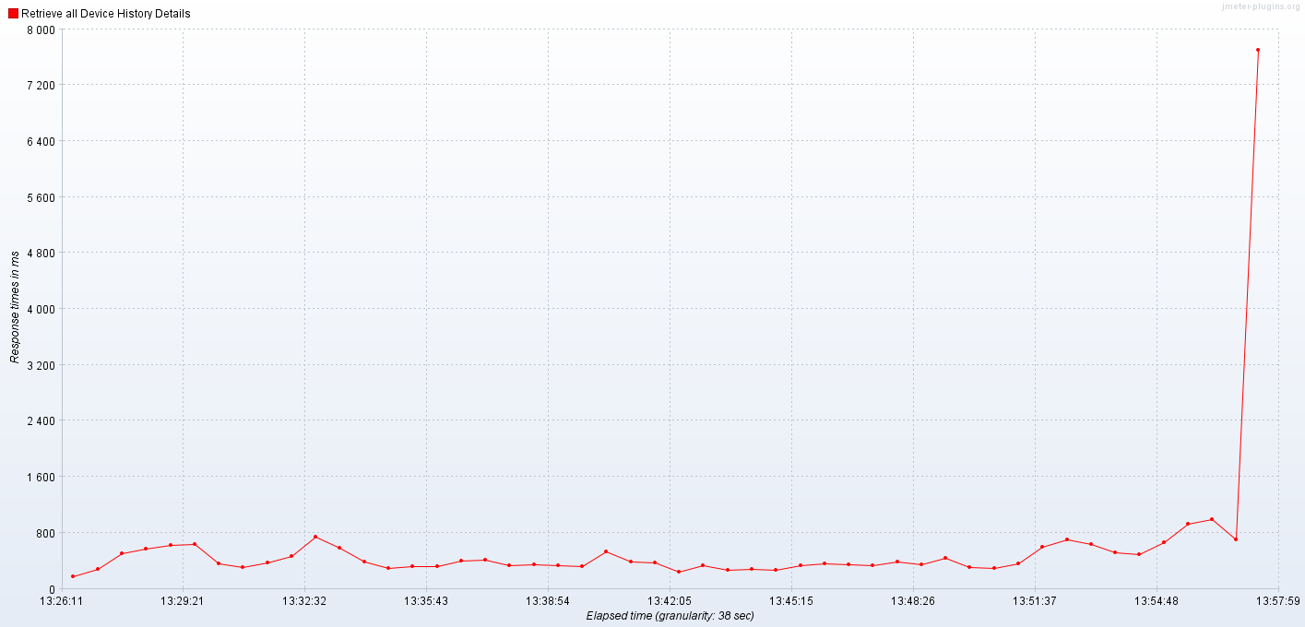

Bytes Throughput Over Time (bytes/sec)

